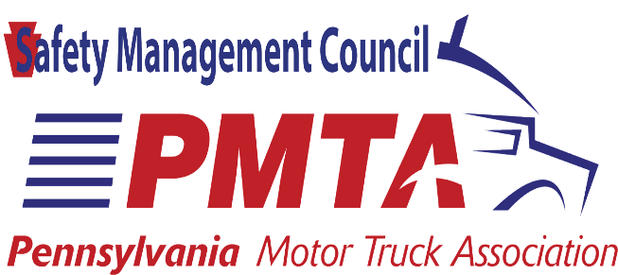

PENNSYLVANIA ROAD TEAM

NOMINATION FORM

NOMINATIONS ARE OPEN TO QUALIFIED DRIVERS OF PMTA MEMBER COMPANIES IN GOOD STANDING AND SHALL BE PROVIDED AND VERIFIED BY THE NOMINATOR. DEADLINE FOR APPLICATION IS APRIL 4TH, 2022

CANDIDATE
Name_______________________________________________________________________________
Home Address________________________________________________________________________
City, State, Zip Code____________________________________________________________________
Phone number________________________________________________________________________
Email Address_________________________________________________________________________
NOMINATOR
Name_______________________________________________________________________________
Company____________________________________________________________________________
Business Address______________________________________________________________________
____________________________________________________________________________________
Business Phone Number________________________________________________________________
Email Address_________________________________________________________________________

THE FOLLOWING MUST BE INCLUDED IN THE NOMINATION PACKET
- Candidate Statement- The candidate must submit a letter describing why he/she would like to represent the trucking industry as a member of the Pennsylvania’s Road Team
- MVR current within 30 days of submission of form
- A current photo of the candidate

Candidate Profile
Candidate’s Employer _______________________________________________________________________________
Local Business Address (Terminal) _______________________________________________________________________________
Business Phone____________________________________________
Candidate’s immediate supervisor or primary terminal contact____________________________
Title __________________________________________________________________________
Phone _____________________________ Email______________________________________
Type of Carrier: Truckload, LTL, Hazmat, Private fleet, Other: ______________________________________________________________________________
Describe candidate’s typical route (i.e., Harrisburg to Scranton) ______________________________________________________________________________
Describe the candidate’s driving assignment city, line haul,etc. ___________________________
What commodities does candidate typically carry? (Examples: general freight, produce, petroleum, etc.) _______________________________________________________________________________
Is the candidate an owner-operator? Yes No
How many years has the candidate been a professional truck driver? ___________
How many years with current employer? ____________
How many miles has the candidate accumulated in his/her career? _____________
How many accident-free? ________________________
Has the candidate ever been involved in an accident—either preventable or non-preventable—while driving a truck? ____________________
If yes, describe each accident on a separate sheet of paper making sure to include: • the date of occurrence • the circumstances • whether the accident was ruled preventable or non-preventable
If candidate has been involved in a PREVENTABLE accident, how many miles has he/she accumulated since the last PREVENTABLE accident? (Please note date of last accident) ________________________________________
Please list on a separate sheet any moving violations charged to the candidate while driving a commercial vehicle or personal automobile.

Candidate’s Industry Activity
PLEASE ATTACH DOCUMENTATION FOR ALL ACTIVITIES
ATTACH ADDITIONAL PAGES IF NECESSARY
Please list any industry-related honors or awards, including company awards, the candidate has received. (examples: truck driving championships, million-mile safe driving award, 10-year safe driving award,etc.).________________________________________________________________________________________________________________________________________________________________
Please list candidate’s hobbies and/or special interests, _______________________________________
_____________________________________________________________________________________
List any previous speaking experience and/or media training. Include presentations at company or industry functions______________________________________________________________________
_____________________________________________________________________________________
List the candidate’s community service or leadership activities and recognition_____________________
_____________________________________________________________________________________
On a separate page, why should your candidate be considered for nomination to Pennsylvania’s Road Team
ALL OF THE INFORMATION CONTAINED IN THIS NOMINATION FORM AND ANY ATTACHED DOCUMENTIONS IS ACCURATE AND TRUE TO THE BEST OF MY KNOWLEDGE
Name of Nominator___________________________________
Signature of Nominator________________________________
Title______________________ Date_____________________
Completed form and attachments must be mailed (NO fax) or delivered in person to:
PMTA- Road Team
910 Linda Lane
Camp Hill, PA 17011

